2.3 Orange Local Environmental Plan 2011 - Amendment 4 Shiralee Post Exhibition

TRIM REFERENCE: 2015/2322

AUTHOR: Craig Mortell, Senior Planner

**EXECUTIVE Summary**

Draft Orange Local Environmental Plan 2011 – Amendment 4 was placed on public exhibition between 13 December 2014 and 10 February 2015. Consultation with government departments and agencies was also commenced at this time but took several months to be completed. Parliamentary Counsel opinion has been sought and was provided to Council on 9 September 2015, confirming that the draft plan can be legally made.

This report evaluates the matters raised in submissions and outlines how issues have been addressed. Council will be aware that Amendment 4 to the Local Environmental Plan (LEP) follows on from extensive community consultation that was undertaken during the preparation of the Shiralee Development Control Plan (DCP) Master Plan. The amendment is therefore primarily intended to make the LEP and DCP consistent with the result of that exercise.

Review of submissions has therefore been informed by the earlier process, such that significant changes have been deemed to be inconsistent with Council’s already adopted DCP Master Plan for the area.

**Link To Delivery/OPerational Plan**

The recommendation in this report relates to the Delivery/Operational Plan strategy “1.2 Our City - Information and advice provided for the decision-making process will be succinct, reasoned, accurate, timely and balanced”.

**Financial Implications**

Nil

**Policy and Governance Implications**

Nil

*Do not delete this line*

|  |
| --- |
| **Recommendation**  **1 That Council authorise the General Manager to formally make Orange Local Environmental Plan 2011 – Amendment 4.**  **2 That Council remove the Shiralee area from the Urban Release Area map so as to reduce any confusion during assessment of future development applications.**  **3 That staff request the Department of Planning and Environment to proceed with notification of the amendment through publication on the Parliamentary Counsel website.** |

*Do not delete this line*

**further considerations**

Consideration has been given to the recommendation’s impact on Council’s service delivery; image and reputation; political; environmental; health and safety; employees; stakeholders and project management; and no further implications or risks have been identified.

**SUPPORTING INFORMATION**

Submissions were received from two land owners and two government agencies during the exhibition period.

**6 Cherrywood Close**

The owners of 6 Cherrywood Close requested a change in minimum lot size from 2,400m2 to 2,000m2 on the Cherrywood Close frontage of their block and a reduction in the minimum frontage requirement of 40m to 30m. They suggest that the current minimum lot size would allow for eight lots on their property but due to the minimum frontage requirement of 40m they can only design for seven. The change sought would allow for a total of nine lots.

The large lot classification table on page 18 of the Master Plan establishes the minimum size of 2,400m2 applying to lots along Pinnacle Road, Shiralee Road (north of the Southern Feeder Road), Cecil Road and the Southern Feeder Road with a minimum width of 40m while allowing a 30m width for lots accessed from side roads. This combination of size and lot width helps to preserve an open appearance along key entrance roads to the Shiralee area.

The submission applied the 40m frontage requirement to the side roads of Cherrywood Close and Pines Lane however in such cases only a 30m frontage is required. The image below illustrates the submitters design on the left, suggesting that only seven lots would be possible, and a fully compliant design on the right showing that an eight lot design is achievable. Note that the top of the image is the Shiralee Road frontage that requires a 40m lot width (left and right sides roads only require a 30m width).

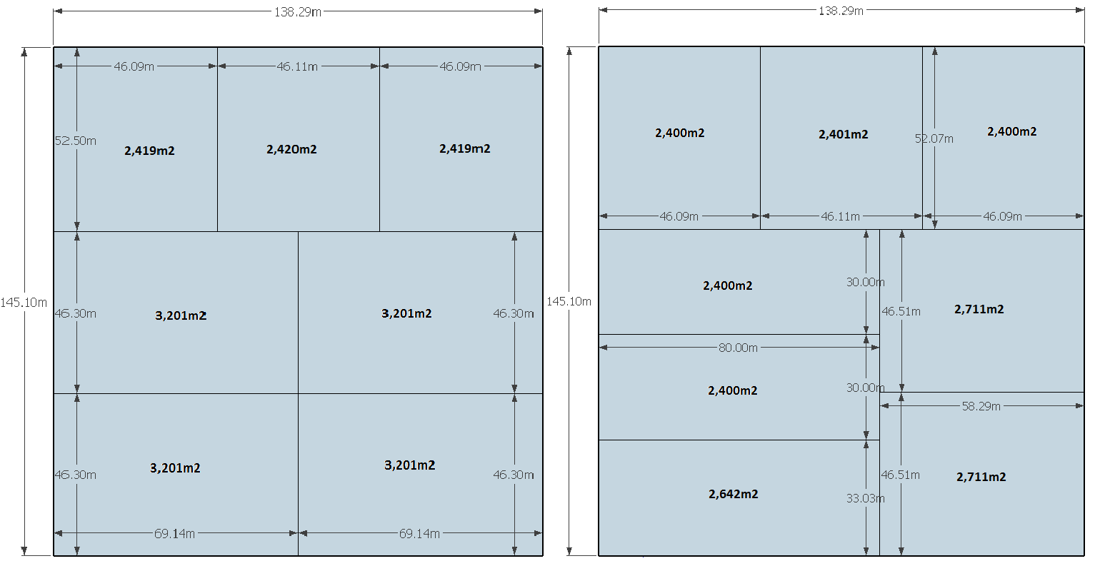

**Landowner’s design on left (only seven lots achieved). Fully compliant eight lot design illustrated on right.**

Other design responses may also be viable. Accordingly, no change is recommended to either the minimum lot size or the minimum frontage requirement in this case. This will maintain consistency with other large lot properties in the vicinity.

**46 Shiralee Road**

The owners of 46 Shiralee Road re-lodged a submission they made during the Shiralee DCP Master Plan project and included an update letter relating to four specific matters they considered to remain of concern. The four main areas of objection concerned the following

1. Threats to biodiversity and watercourses in the area to the west of 46 Shiralee Road
2. Changes to the number and size of residential lots that occurred between the initial exhibition of the Shiralee Master Plan in May 2014 to the version adopted in September 2014
3. Impacts on the amenity of 46 Shiralee Road and future development potential of that land
4. The process by which the changes occurred between exhibition and adoption of the Master Plan (May to September 2014)

Issue 1 relates to a pair of dams that Council has acquired to serve two roles, firstly in stormwater retention and management and secondly as part of the extensive public open space network. This area will be subject to significant landscaping earthworks to provide for this mixed role and early designs suggest that the site will be able to incorporate native plantings and habitat areas. While there will be disruption to the site it is considered that the current contribution to biodiversity and water quality values will ultimately be enhanced.

Issues 2 and 4 are clearly related. As Council will be aware the Master Plan changes, which introduced the medium lot typology, were the result of the public exhibition period and negotiations that held with a range of different landowners. In part the increased number of lots, and corresponding decrease in size, were the result of needing to achieve an overall yield that would keep developer contributions at a reasonable level. The criticism that the increased density was localised to the land south of 46 Shiralee Road is attributable to the concept of creating a range of neighbourhoods at differing scales and densities across the Shiralee precinct. This invariably means that some areas will have greater or lesser density than others.

Issue 3 speaks to changes to the amenity of 46 Shiralee Road, which is largely related to the inclusion of a row of compact lots to the western edge of their property, rather than an uninterrupted view over the dam/open space corridor. Again the placement of these lots is consistent with the Master Plan principle of placing density in locations that can benefit from available sources of amenity. In most cases compact lots across Shiralee will open onto public open space or across larger lots, effectively “borrowing” the landscaping on those larger parcels.

The processes undertaken with the Shiralee Master Plan were in accordance with the requirements of the Environmental Planning and Assessment Act 1979 and the result of extensive public exhibition and consultation. This LEP amendment is seeking to have the outcome of that master planning exercise incorporated into the LEP maps and provisions. The submission has not established any significant grounds to abandon the LEP amendment as exhibited.

**Crown Lands**

A submission was received from Crown Lands providing a map of sites that would require further discussion regarding incorporation of roads to be used in the development as access and green space areas. These are essentially matters that will be addressed during future development applications or in some instances a separate negotiation process with crown lands.

**Roads and Maritime Services**

The Roads and Maritime Services (RMS) sought clarification on the future traffic volumes and road network integration in order to confirm that no additional state infrastructure would be required. Council responded to their request for information and RMS advised of no further concern.

The Department of Planning and Environment liaised with a range of other government departments and agencies to confirm that state infrastructure contributions would not be required.

**Urban Release Area**

The Shiralee area was added to the Urban Release Area (URA) map of the LEP when the land was rezoned under Amendment 1. This provided the opportunity for Council to confirm where urban expansion was to occur yet defer development in order to undertake the DCP master planning exercise that could establish a preferred urban design.

Due to the URA mapping the post exhibition process had to involve a prolonged period of government agency consultation in order to confirm that the Shiralee area did not generate a need for state level infrastructure such as new public schools, hospitals or highways. While most agencies were able to readily form that view, the timing of this post-exhibition report has been delayed in order to satisfy the concerns of all departments and agencies.

Council adopted the Shiralee DCP master plan in September 2014, thereby satisfying the URA requirements. Retaining the Shiralee area in the URA map has therefore become redundant. The site should be removed from the URA map to avoid any possible doubt or confusion for future development.

*Do not delete this line*

**Attachments**

1 Request change to Shiralee Masterplan - reduce block frontage size - Cherrywood Close and Pines Lane - Tony Reppen and Judy Reppen, IC14/15985

2 Submission - Shiralee Master Plan - Garry Smith and Lesley Smith, IC15/412

3 Further discussion needed Crown Roads - response Amendment 4 Shiralee DCP Master Plan, IC15/855

4 Roads and Maritime Services submission on OLEP Amendment 1 regarding Shiralee - OLEP Amendment 4 - 6 March 2015, IC15/3116

5 Orange Planning Proposal Shiralee - condition 3 satisfied, D15/35040

6 Orange Urban Release Area certification, D15/35038

7 Parliamentary Counsel Opinion, D15/35056

8 mapping cover sheet, D15/35052

9 Draft URA map, D15/35042

10 Draft LRA map, D15/35043

11 Draft LSZ 8A map, D15/35046

12 Draft LSZ 8B map, D15/35047

13 Draft LZN 8A map, D15/35048

14 Draft LZN 8B map, D15/35049